Rules of Hare and Hounds
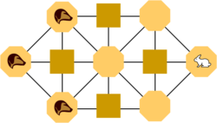
A starting position for a game of Hare and Hounds
- One player represents the three Hounds, which try to corner the other player's Hare as it seeks to win by escaping them.

- The Hounds move first. Each player can move one piece one step in each turn. The Hounds can only move forward or diagonally (left to right) or vertically (up and down). The Hare can move in any direction.

- The Hounds win if they "trap" the Hare so that it can no longer move.

- The Hare wins if it "escapes" (gets to the left of all the Hounds).

- If the Hounds move vertically ten moves in a row, they are considered to be "stalling" and the Hare wins.
Rules of the game
A starting position for a game of Hare and Hounds
- One player represents the three Hounds, which try to corner the other player's Hare as it seeks to win by escaping them.

- The Hounds move first. Each player can move one piece one step in each turn. The Hounds can only move forward or diagonally (left to right) or vertically (up and down). The Hare can move in any direction.

- The Hounds win if they "trap" the Hare so that it can no longer move.

- The Hare wins if it "escapes" (gets to the left of all the Hounds).

- If the Hounds move vertically ten moves in a row, they are considered to be "stalling" and the Hare wins.

